- CSRF
  - CSRF (Cross-Site Request Forgery) is an attack where a malicious website tricks a logged-in user’s browser into sending an unauthorized request to a trusted website using the user’s existing session/cookies.
  - So basically, CSRF attacks doesn’t steal password; It uses user’s cookies stored in the browser to steal the data/money.
  - So, to prevent CSRF, either you need to pass some unique token in the request headers or make the request bind with a particular website (means other website cannot send that request)
  - Someone can steal your cookies, but they don’t have your headers.
- With csrf token, it can be prevented.
  - 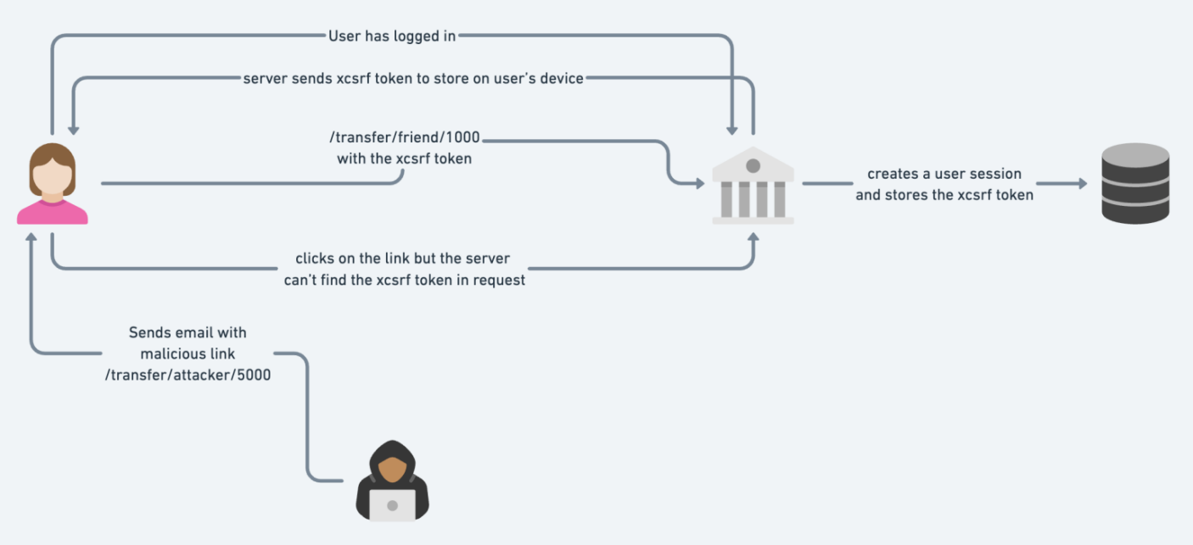

Internal Working Of Spring Security
- The dependency spring-boot-starter-security has to be added in pom.xml which groupId is org.springframework.boot
- After that spring-boot will auto-configure the security with sensible defaults defined in WebSecurityConfiguration class.
- 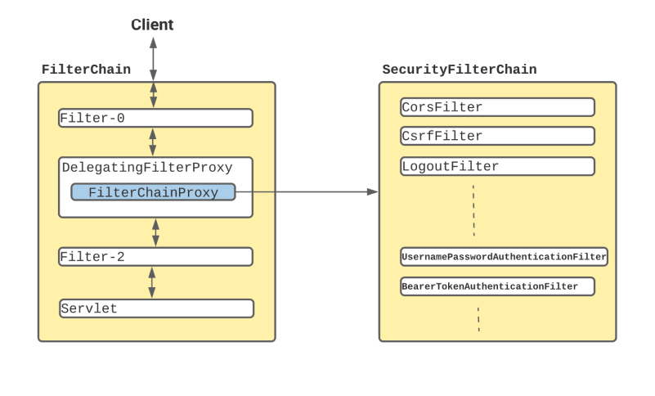
  - In Spring Boot application, SecurityFilterAutoConfiguration automatically registers the DelegatingFilterProxy filter with the name securityFilterChainRegistration (method name will be same as Bean name).
  - Once the request reaches to DelegatingFilterProxy, Spring delegates the processing to FilterChainProxy bean that utilizes the SecurityFilterChain to execute the list of all filters to be invoked for the current request.
- Default behaviour of Spring-Security
  - Creates a bean named springSecurityFilterChain & registers the filter with a bean named springSecurityFilterChain with the Servlet container for every request.

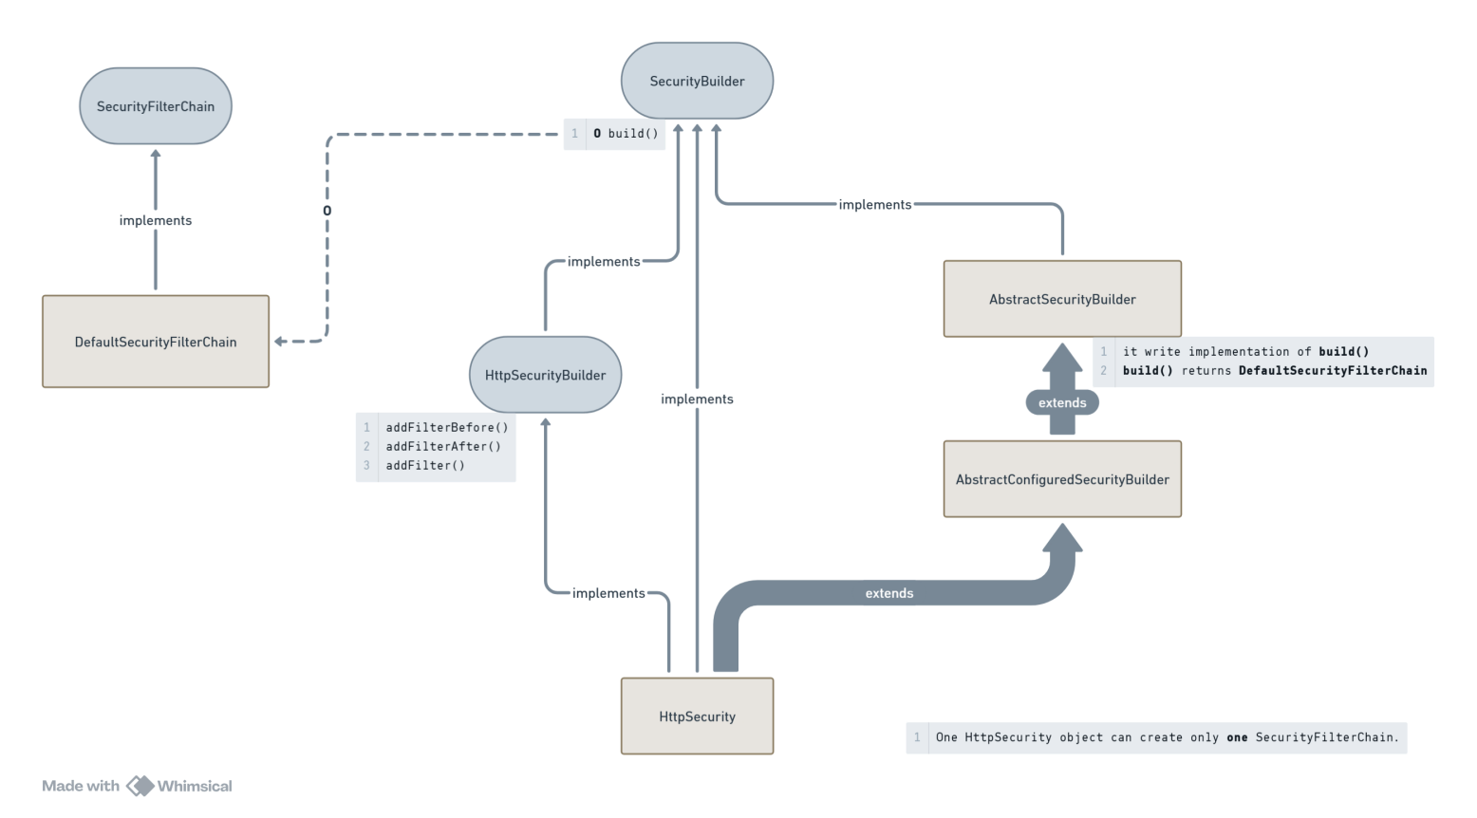
- This is the flow of Security Filters.
- In the class WebSecurityConfiguration, the beans are created.
  - The bean of HttpSecurity is created.
    - 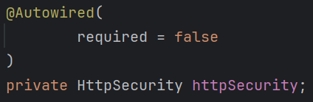
  - One HttpSecurity type of object can build only one SecurityFilterChain.

- HttpSecurity contains build() method that returns object of type DefaultSecurityFilterChain. Then why Spring needs to create a bean of SecurityFilterChain ?
  - WebSecurityConfiguration has a list of SecurityFilterChain
  - Here one method is there to create the bean named as springSecurityFilterChain.
    - 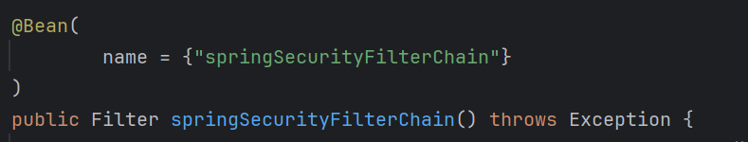
    - But here, Filter is the return type; confusing; will discuss at the end :)
  - If there is no filter chains, it’ll add the default chain from HttpSecurity build() method.
    - it’ll not add the default chain to the list i.e. securityFilterChains, rather it is being added to webSecurity object.
    - It is being added here (WebSecurity class).
    - 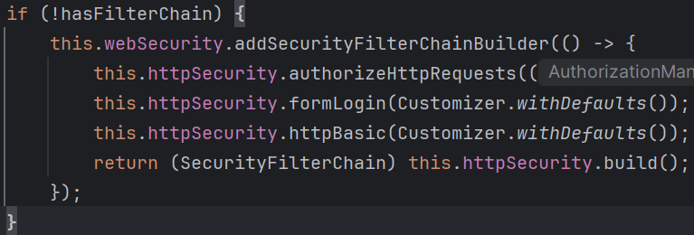
  - If filter chains are already there, then it add those filter chains to webSecurity object.
    - 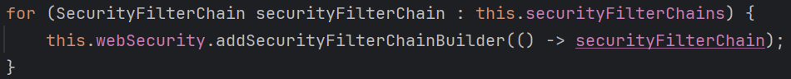
  - At the end it’ll return an object of type Filter

- Spring Filter Behind the Scene
- What we see, chain of filters are being executed in between Servlet Container and Servlet.
  - One servlet containers can have many filters, many servlets; but in case of spring we have only one Servlet which is DispatcherServlet.
  - And, its not by limitation, but by design spring make sure only one Filter should be there in between Servlet Container (tomcat in our case) and Servlet (DispatcherServlet).
  - So, only one Filter should be able to handle multiple Filter Chains where each filter chain contains multiple Filters.
    - its like one object is equivalent to list of ( list of ( the same object ) ).
  - So, FilterChainProxy was introduced which implements Filter. And it contains the list of SecurityFilterChain objects.
    - And the thing is, this SecurityFilterChain class contains a method getFilters() which returns a list of Filter objects.
  - So now, we can return FilterChainProxy object instead of Filter because FilterChainProxy is nothing but the child of Filter.
    - And also it contains list of SecurityFilterChain which means list of ( list of ( Filter )).
- If you want to create your own filter chains.
  - Don’t override the bean creation of the bean springSecurityFilterChain, otherwise spring will only create your bean and all the necessary steps like the below will be skipped.
    - Adding the filter chain to webSecurity.
    - customize using the Customizer object.
  - This all will have to be implemented in your own bean creation method.
  - So, create beans of type SecurityFilterChain
    - 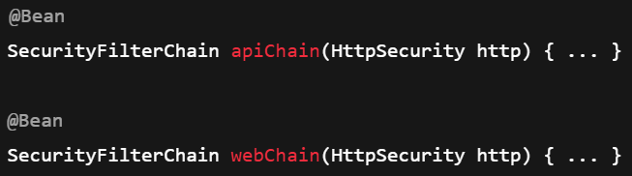
    - Now you might be thinking, if we are creating multiple beans of same type, spring will be confused which bean has to be created; but in this case we spring has list of SecurityFilterChain not a single object of SecurityFilterChain, so all the beans will be added to that list.
      - 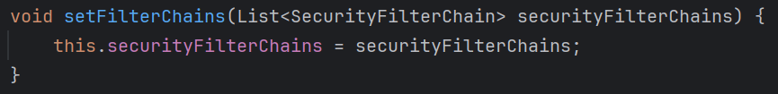
      - This method is inside WebSecurityConfiguration class.
      - All the SecurityFilterChain objects that you created beans of, will be passed to this setFilterChains method.
  - Now, when the list i.e. securityFilterChains (present inside WebSecurityConfiguration.class) has already some elements present, so the default filter chain will not be added to this.
    - 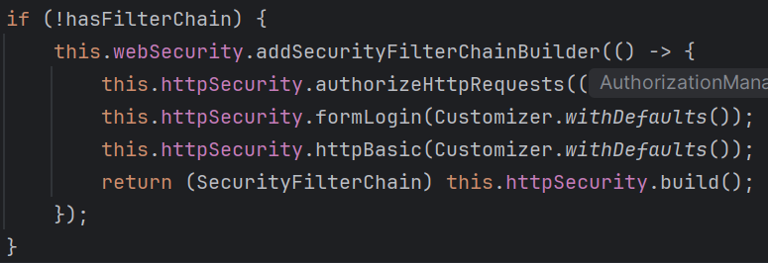

- When you run the application after including the dependency spring-boot-starter-security, by default one login page will appear to authenticate you.
  - If you inspect that, you’ll find one hidden input field containing the csrf token as its value which is being attached to request.
  - 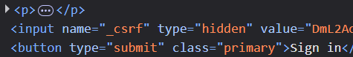
  - Means every time any request being sent, session id (cookie) along with csrf token (request header) are also sent.
- Default Security Filters configurations
  - SecurityFilterChain is an interface containing list of filters.
    - DefaultSecurityFilterChain implements SecurityFilterChain and initializes the filters inside its constructor.
    - But someone needs to call this constructor passing the filters as argument to initialize the filters.
  - HttpSecurity class extends AbstractSecurityBuilder class which contains build() method which returns an object of type DefaultSecurityFilterChain.

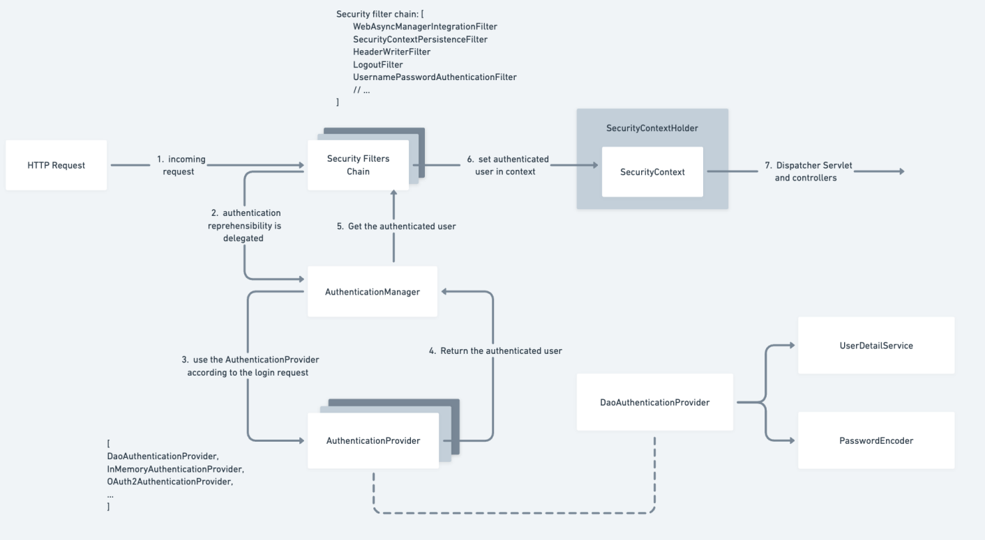
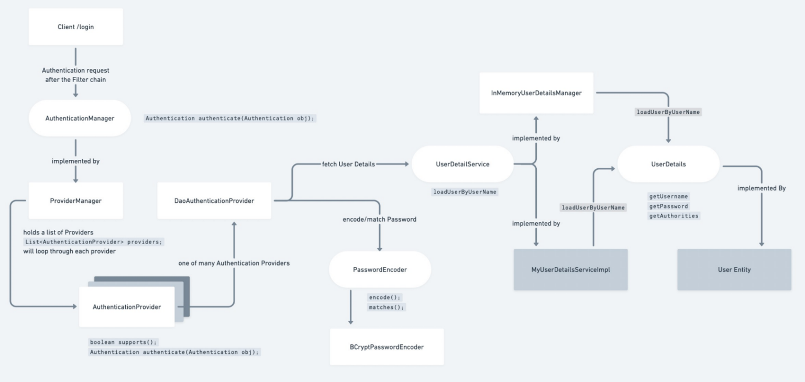
(rectangles: classes, ellipse: interfaces)
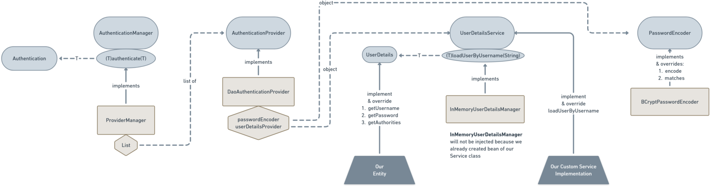
Flowchart of Authentication

- AuthenticationManager is an interface.
  - 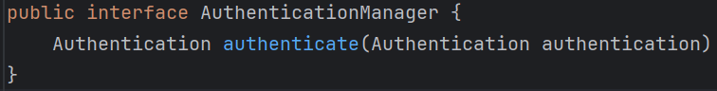
  - Authentication is also an interface containing necessary methods
    - 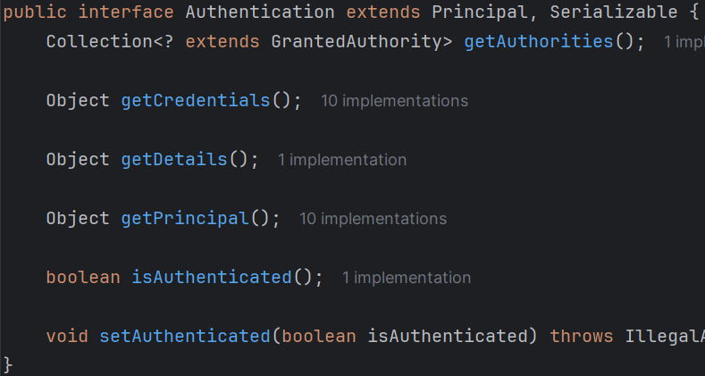
    - After the authentication done,
    - isAuthenticated will be marked as true.
- Now, so many classes implement AuthenticationManager, one of those is ProviderManager
  - It holds a list of AuthenticationProvider (which is also an interface)
- DaoAuthenticationProvider implements AuthenticationProvider
  - It holds the UserDetailsService and PasswordEncoder type of objects.
- UserDetailsService
  - We will implement this interface from our custom Service class and implement the loadUserByUsername method.
  - This method use UserDetails type of object.
- UserDetails
  - Our entity should implement this interface.
- ------------------------------------------------------

- Some Important Points ---------------
  - AuthenticationManager’s authenticate delegates the call to each AuthenticationProvider’s authenticate method.
[ DaoAuthenticationProvider contains list of AuthenticationProvider, and DaoAuthenticationProvider write the implementation of the authenticate method which calls the authenticate method of each AuthenticationProvider ]
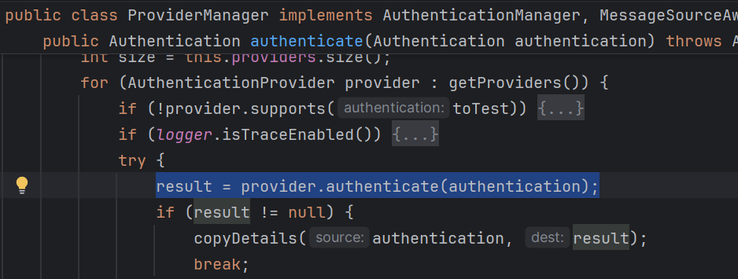
  - DaoAuthenticationProvider extends AbstractUserDetailsAuthenticationProvider which implements AuthenticationProvider.
AbstractUserDetailsAuthenticationProvider writes the implementation of the authenticate method of AuthenticationProvider.
[ when it’ll get a non-null authentication object from provider’s authenticate method, it break; and store the result in AuthenticationToken (copyDetails)]
  - Also, Authentication (interface) extends Principal (interface), and this Principal interface contains a method getName() which returns the username.
If username is stored as principal then it returns directly, otherwise it calls the getUsername() method of the UserDetails object. [ which is implemented by our Entity ]
this getName() method is present inside AbstractAuthenticationToken (abstract class) which implements Authentication (interface)
    - 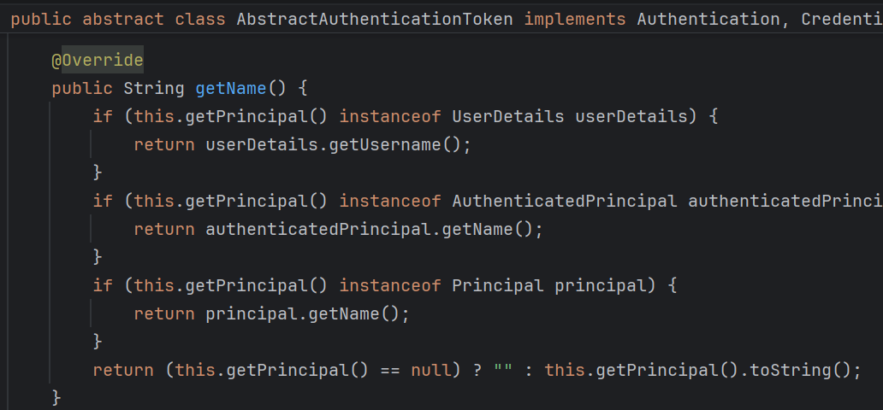
  - F
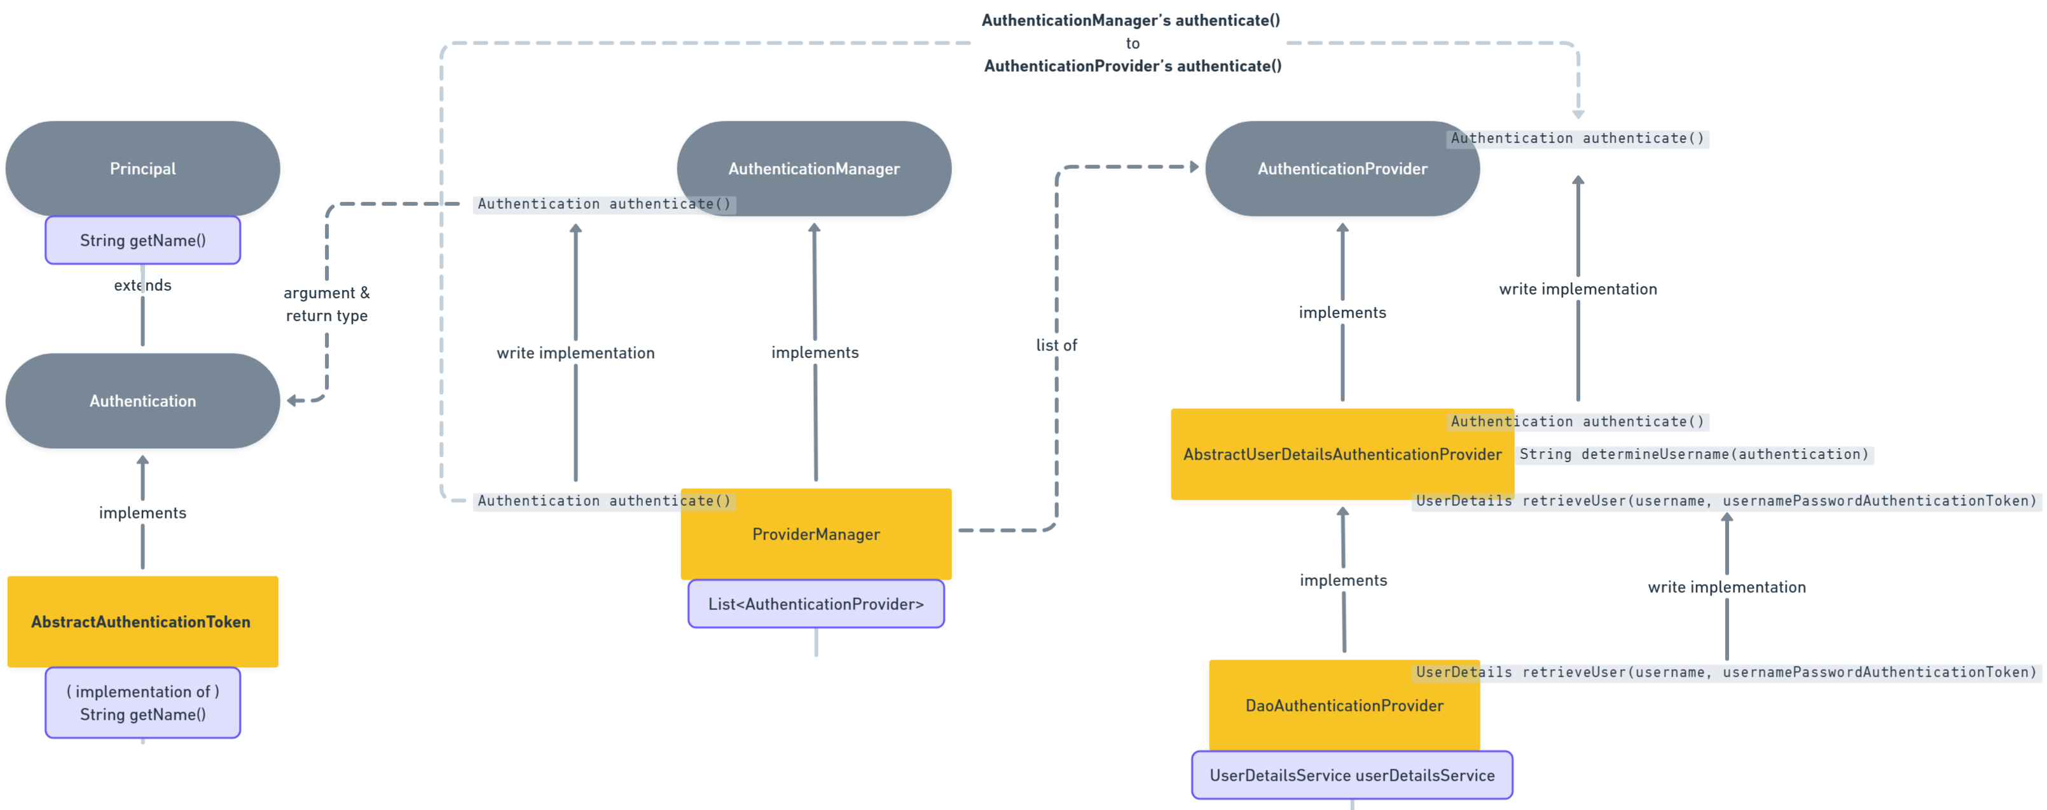

- Writing custom Filter Chains
- We’ll create the custom filters like the below
  - 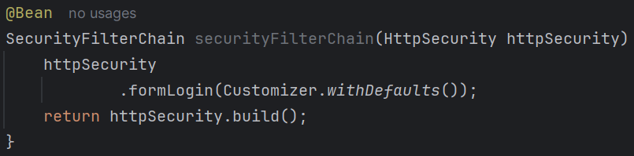
  - You might be thinking, while creating the bean, how this HttpSecurity type of objects is being coming; as according to what we were doing earlier, it didn’t have any argument in the @Bean method.
  - You can mention any type of argument you want in the @Bean method, if that type of bean is created, then Spring will automatically inject that bean to your @Bean method’s argument.

- Lets say we want to write our own UserDetailsService and UserDetails
  - As we know, by default InMemoryUserDetailsManager implements the UserDetailsService interface implementing the loadUserByUsername method.
    - It is responsible for authenticating the user and password (From the default login form of spring security) being mentioned in the application.properties file.
  - If we want to write our own service, then InMemoryUserDetailsManager bean will not be created; rather our service bean will be created in place of that.
  - So, to write custom user details and the service, we need to do the following:
    - Extend the UserDetails from our User entity
    - Extend the UserDetailsService from our UserService
      - In this UserDetailsService, write the implementation of the method loadUserByUsername.
- I wrote the following:
  - In UserService class:
    - 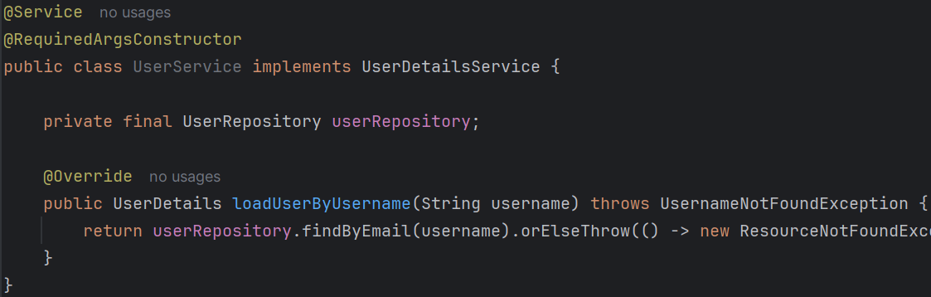
  - In User entity
    - 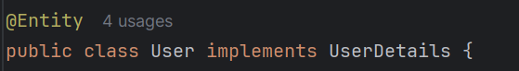
    - 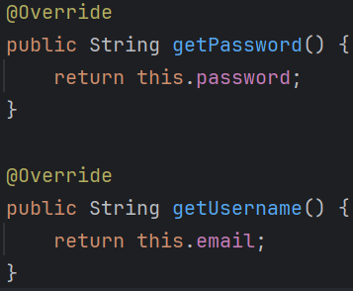
      - These methods are required as there are mentioned in UserDetails interface
    - Now, I added one dummy entry in database
      - 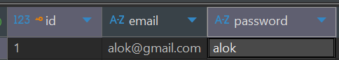
  - Now, If I give alok@gmail.com in the username field and give some random password, it should work right? Because in the loadUserByUserName method I am only fetching the user by username (which is username in our case) and not checking the password.
    - But it’ll not work :)
    - If you remember the diagram:
      - 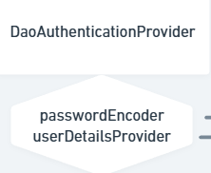
    - We have 2 things here, one is userDetailsProvider (of type UserDetailsService) and passwordEncoder (of type PasswordEncoder)
      - It first get the object returned from the method loadUserByUserName.
      - Then it calls the methods: getUsername and getPassword
      - Now, it validate the password by itself (via the specific hashing algorithm)
      - So, loadUserByUsername is just used to get the object of type UserDetails; remaining verification are done separately.
    - Spring Security uses UserDetailsService only to load a UserDetails object via loadUserByUsername(), then independently calls getUsername() and getPassword() on it and validates the login password using PasswordEncoder.matches() with the configured hashing algorithm.

- PasswordEncoderFactories.class contains createDelegatingPasswordEncoder method which creates the object of password encoders like bcrypt, MD4, MD5 ..etc; there is no configuration file to create bean of any specific Password encoder.
  - 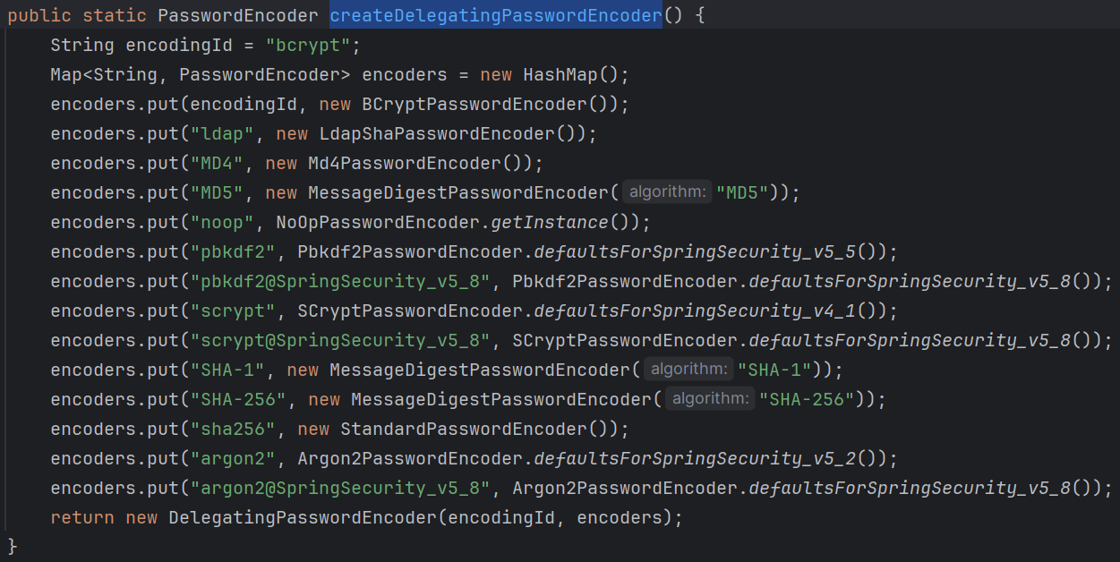
    - (PasswordEncoderFactories.class)
- DaoAuthenticationProvider uses this PasswordEncoderFactories to validate the password.

- For testing purpose of users you can create InMemoryUserDetailsManager bean by yourself (make sure to not create bean of any service that extends UserDetailsService)
  - 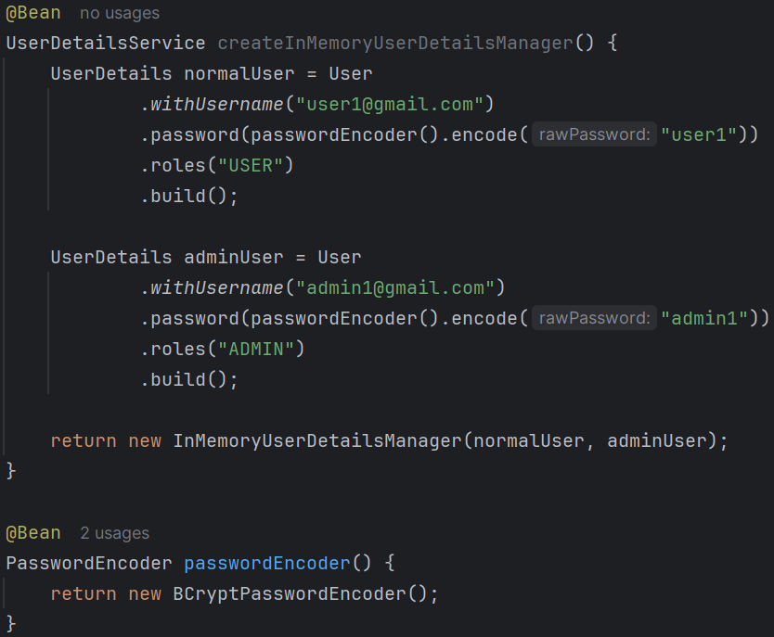
  - If you create a bean of PasswordEncoder then it’ll automatically be injected to the constructor of DaoAuthenticationProvider .
  - Also I restricted some paths for users; only admins can see those;
    - 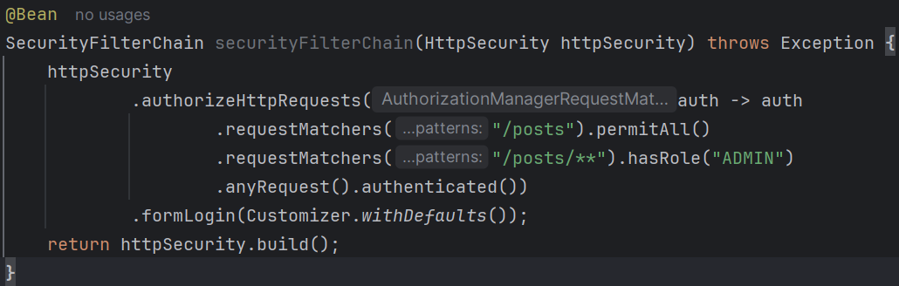
  - This is how you can manage the routes;

- JWT
- 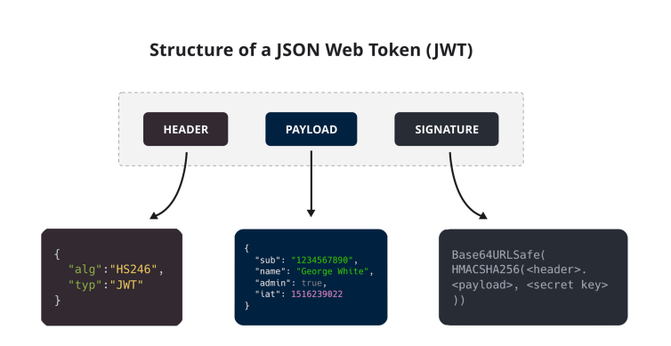
- 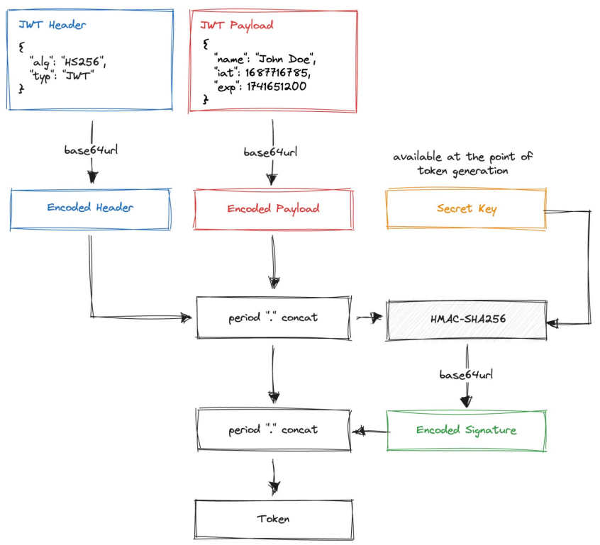
- 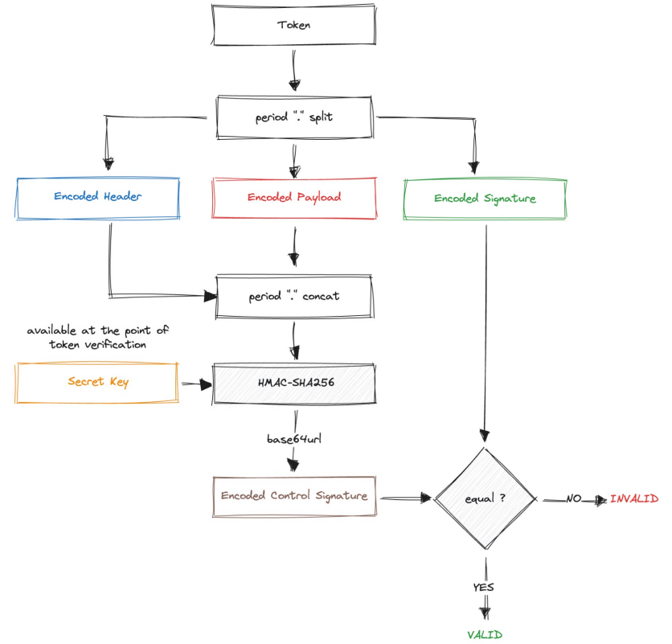
- 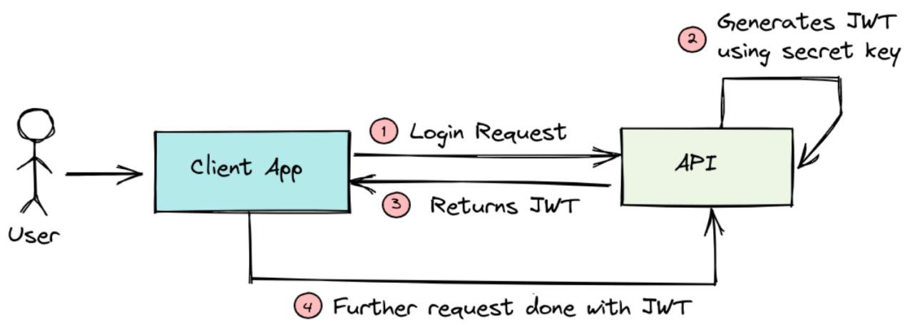
- F
- F
- F
- F

- There are 2 things:
  - FilterChain
    - Provided by Servlet container (Tomcat)
  - SecurityFilterChain
    - Provided by Spring Security.
    - It is just a callback handle to “who comes next”
- FilterChain and SecurityFilterChain looks similar but both are different.
  - FilterChain is like a middleware that is used to connect the filters of the SecurityFilterChain.
  - Its just a callback, means if one filter passes then FilterChain will be the one who’ll call the next filter; if fails then it stops.
  - There is a method doFilter inside the FilterChain interface, which is being called in each filter.

- Creating JwtService
- 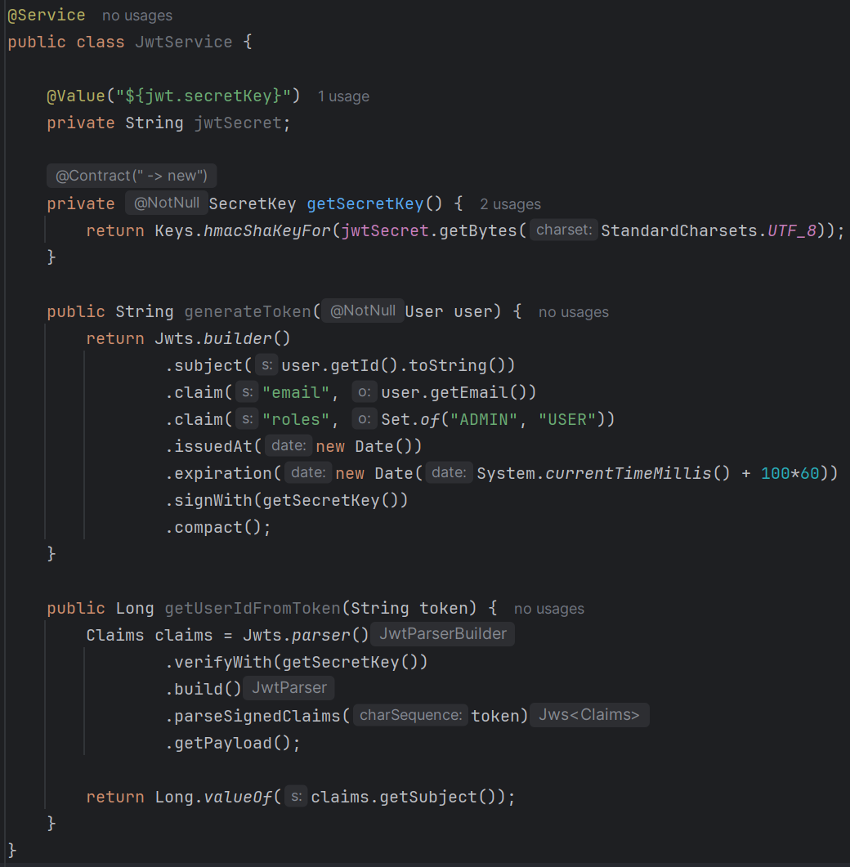
- subject : it defines the owner; usually give the unique key as subject. getPayload()
- claims : it is just some additional details that you can give. get(“claim_key_name”)

- Important Points
- JWT filter is used for authentication; not authorization;
- For login, you don’t want the user to be authenticated:
  - Either you can use form login (which is not recommended), it uses UsernamePasswordAuthenticationFilter by default.
  - Or you can directly go to controller and there you can check the username and password;
    - If the credentials are proper then generate one token and return.
    - NOTE: You don’t need to verify the username and password manually; use AuthenticationManager for this.
      - 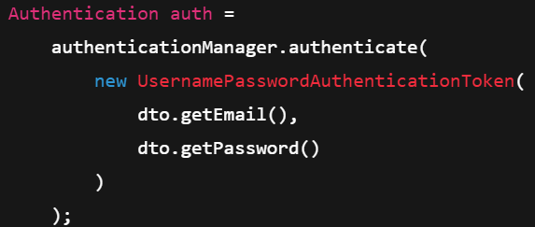
    - One thing might be confusing that how does it go to database and get the hashed password and compare the dto password with that;
    - Here, authenticationManager.authenticate() delegates the call to authenticationProvider.authenticate() , and this retrieve the user details calling the method loadUserByUsername that is being written by us in the service class that extends UserDetailsService.
  - tomcat --- controller --- authentication manager
- For accessing any protected path (paths which are being mentioned with authenticated() )
  - Request will come with the authorization header containing the JWT token.
  - It’ll then go to JWT filter (written manually)
  - Here it’ll validate the token, and store the authentication in the SecurityContext.
  - SecurityContext is accessible in the current request thread to get the details of current authenticated user.

- F
- F

- NOTE
  - You don’t need to create bean of AuthenticationManager manually, if you are creating bean of PasswordEncoder and UserDetailsService, spring will automatically create AuthenticationManager using DaoAuthenticationProvider as the AuthenticationProvider.
  - Because UserDetailsService is only related to the DaoAuthenticationProvider and not related to any of the other providers.
  - 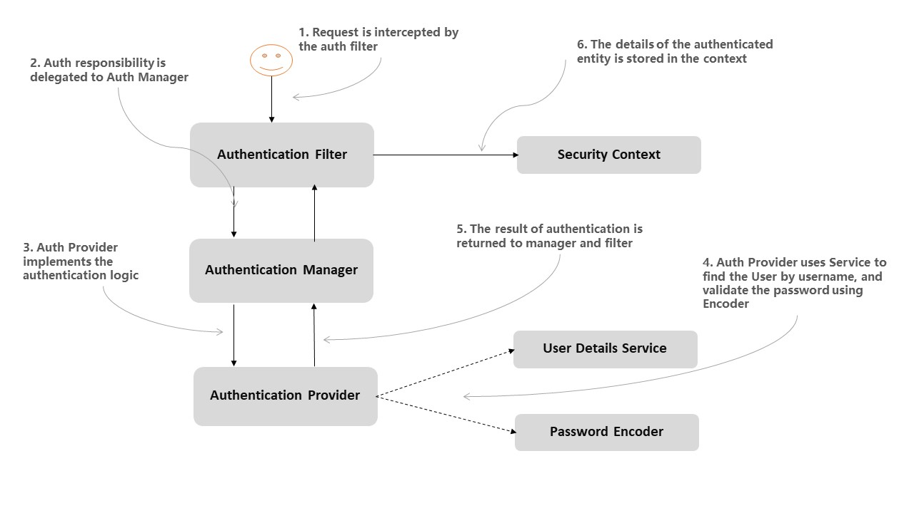
  - It’ll be true only if you have not done any of the following: otherwise you need to create the bean of AuthenticationManager by yourself.
    - ❌ Create your own SecurityFilterChain
    - ❌ Customize HttpSecurity
    - ❌ Add JWT / custom filter
    - ❌ Disable formLogin / httpBasic
    - ❌ Use stateless session
    - ❌ Create custom authentication logic
  - 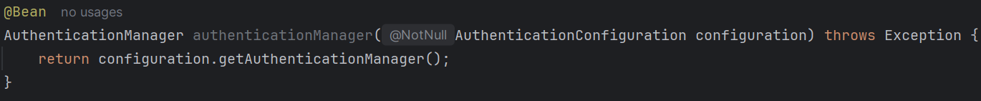

- Cyclic Dependency
- Sometimes you might get the following type of Exception
  - 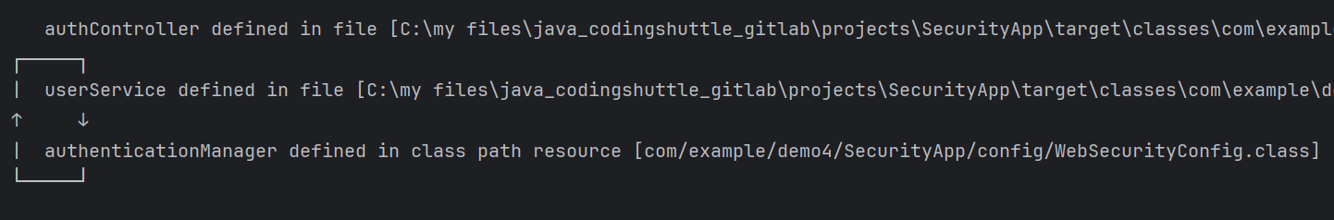
  - You need to avoid this type of cyclic dependencies.
  - Here I got this exception because,
    - AuthenticationManager uses UserServiceDetails which uses UserService
    - And I am using AuthenticationManager inside UserService.
    - AuthenticationManager -- UserService -- AuthenticationManager -- UserService -- -- -- -- -- --
- httpSecurity’s authentication() vs JWT Filter -------------------------------------------
  - It is confusing that, if we are already checking the token with JWT Filter then why do we even write authenticated() on the protected routes.
  - authenticated() checks SecurityContext
    - if it contains Authentication object: user is authenticated;
    - Else: user is not authenticated.
  - ------------------------------------------------------------------------------------------
  - In JWT Filter, we check the token and add the user details in the SecurityContext, so Spring Security now knows that user is authenticated.

- Principal vs Credentials vs Authorities in Authentication Object
- Principal -------
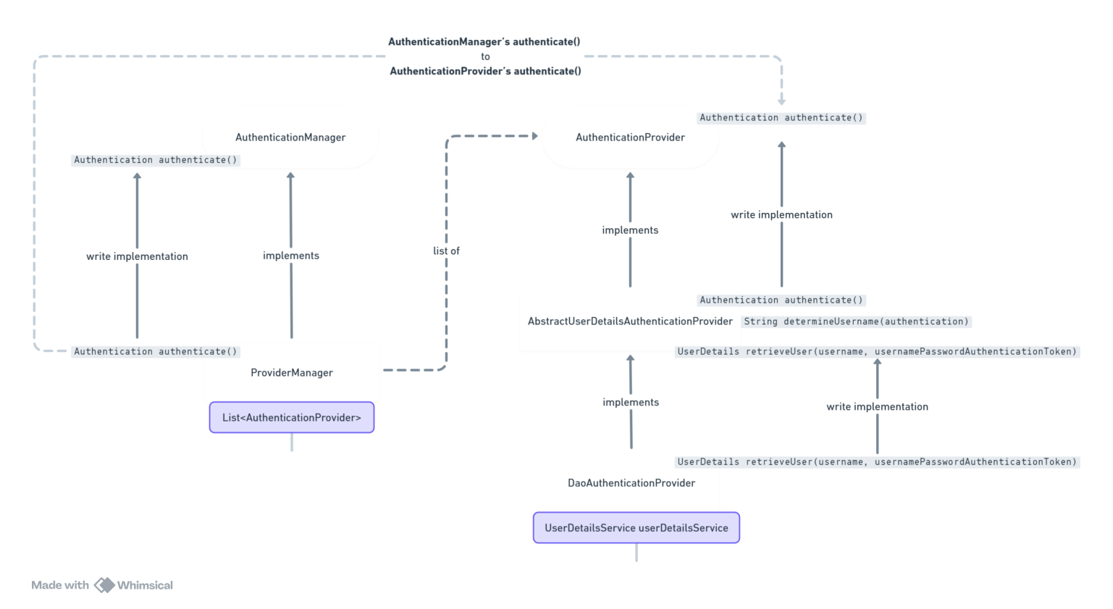
- If you pass UserDetails type of object, then it must be having getUsername() method.
  - 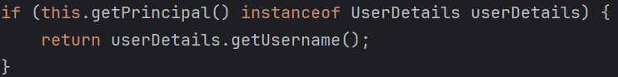
  - AbstractAuthenticationToken.class
- AuthenticationProvider's authenticate() calls determineUsername()
- determineUsername() calls authentication's getName()
- Inside getName(), it'll check the type of principal
  - if it is UserDetails type then it'll call getUserName() method;
  - if it is String, then it'll return it simply.
  - 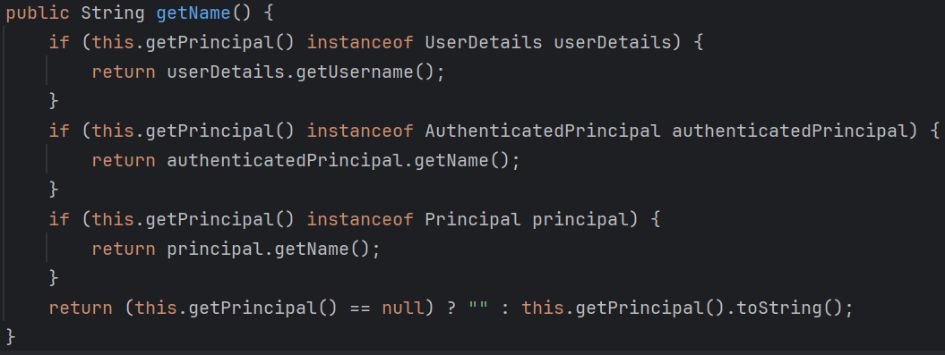
- after getting username, it calls the retrieveUser() method to get the object of type UserDetails.
- DaoAuthenticationProvider keeps the bean of type UserDetails to call the loadUserByUserName() method passing the username.
  - 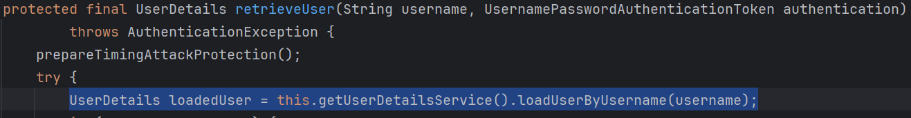

- Credentials -------
- Here you’ll pass the raw password (not the hashed password)
- Authorities -------

- Login Flow with JWT
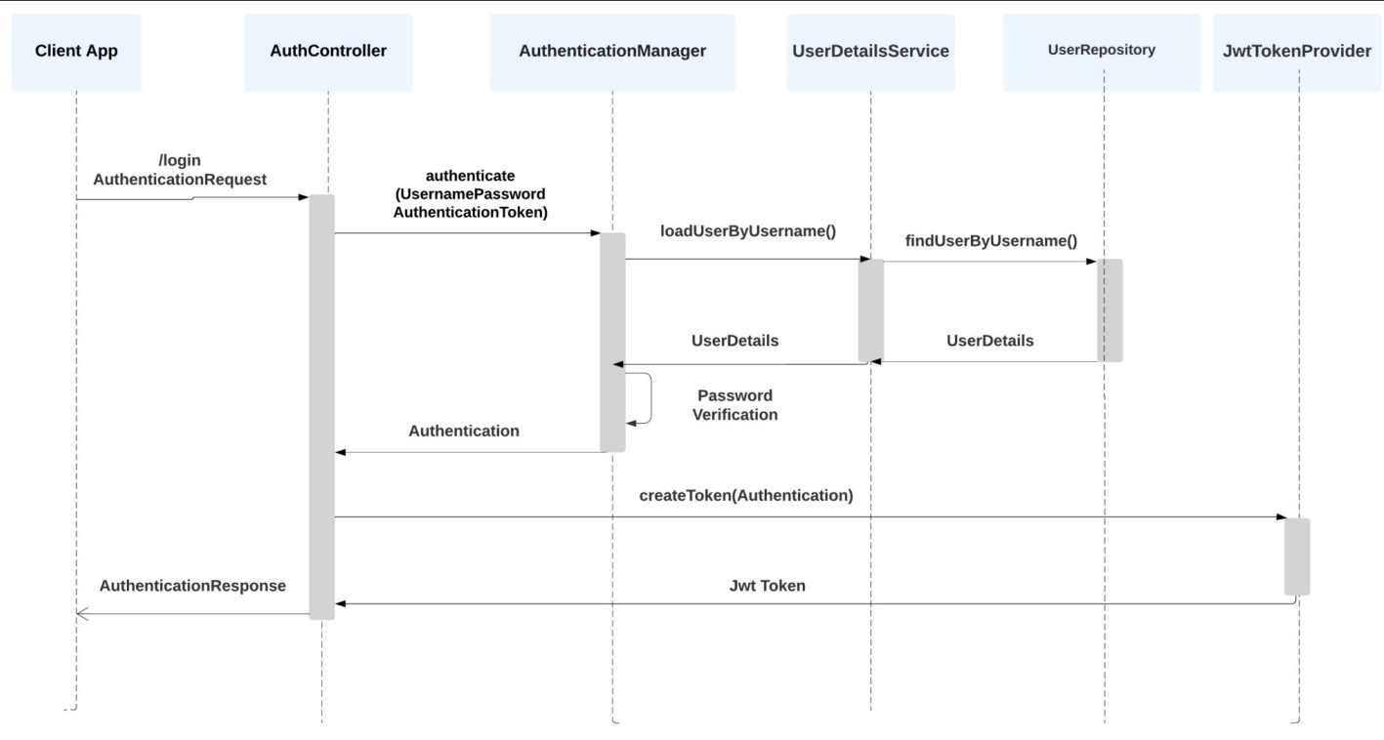
- Authentication Workflow with JWT
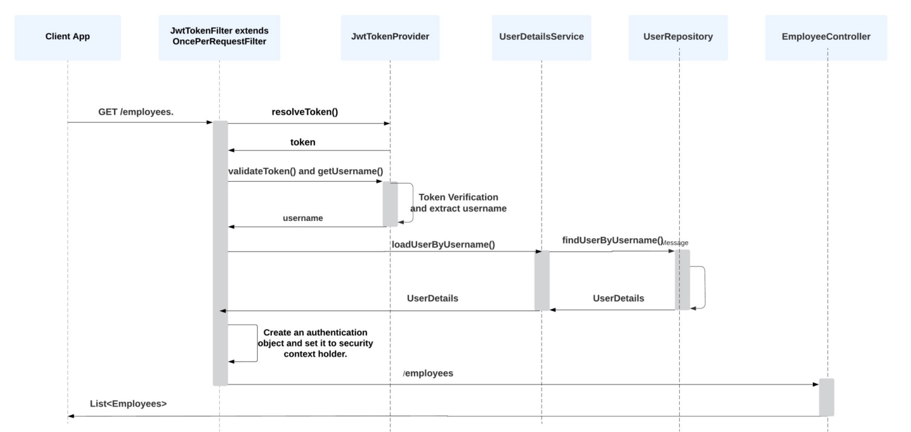

- JWTAuthFilter Control Flow
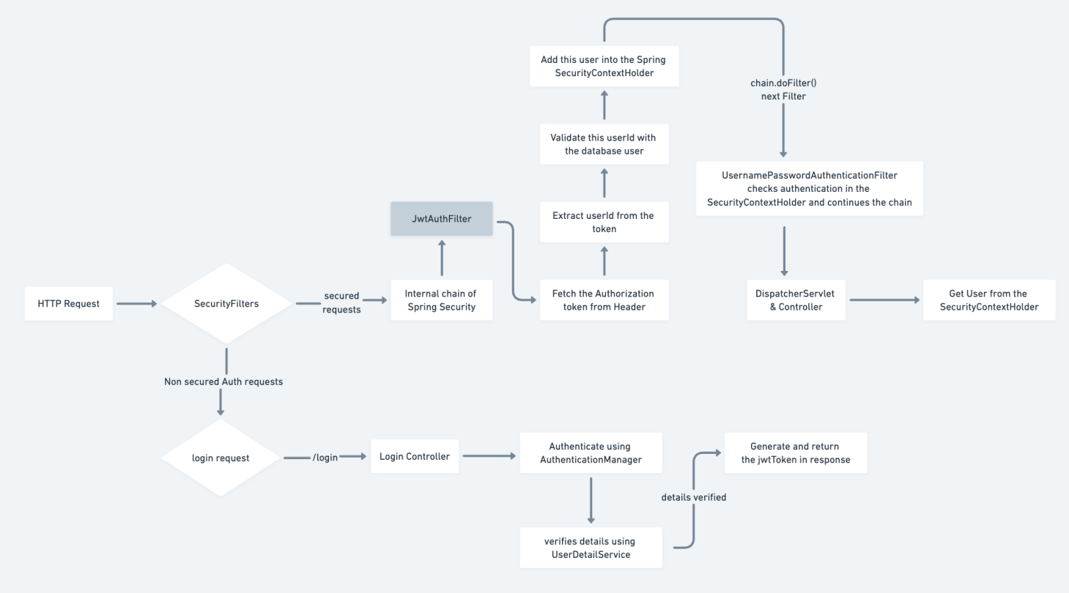

Udemy Part
- Client --- Servlet Container --- filter-1 --- filter-2 --- …. --- filter-N --- Servlet
  - 2 way (request and response)
- If you include spring-boot-starter-security, whenever you’ll try to hit any api endpoint, it’ll redirect you to the login page;
  - You need to authenticate yourself with username and password then one session id will be generated and will be stored in the browser cookies .
  - whenever you’ll hit any end-point, that session id will also be attached with the request.
  - By default username id user and password will be generated when you’ll run the spring boot application.
  - For customized username and password, you can write those in the application.properties file.
    - 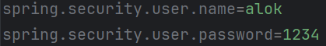
- In the controller, you can get HttpServletRequest type of object which contains details like session id and all.
  - 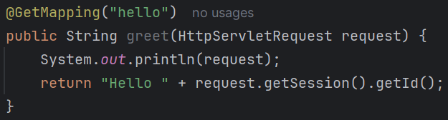
- Get request working; post not working because we are not sending csrf token;
- When you trigger get request, csrf token is not required because its read-only;
  - But, for remaining operations, you need to pass csrf token in the headers.
  - 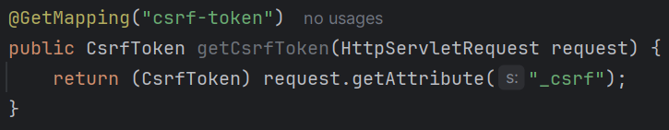
  - I created this end-point to get the csrf token.
    - If you see the default login page generated by spring security, the name will be _csrf here.
    - So the attribute name is _csrf
    - 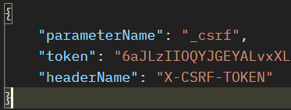
  - While triggering POST request via postman, you need to pass X-CSRF-TOKEN in the headers.
  - It is one way of solving CSRF issue; other way is “Don’t allow any other website to use your session ID”
    - Add this in your application.properties file and it’ll restrict other website to use your session id.
- There are 2 types of application: stateful and stateless.
  - The one we were using now was stateful, because it was using same session ID for all the requests.
  - In case of stateless we need to pass the username & password in each request; so there is no need of csrf token here.

- Spring Security Working
- The filters are present in between the Tomcat and DispatcherServlet’
  - 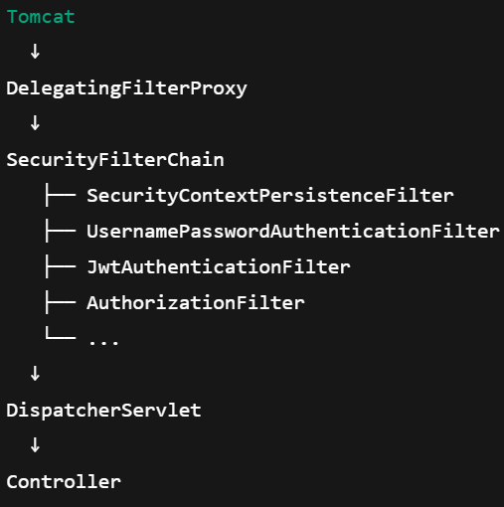
- @EnableWebSecurity
  - It tells Spring “Activate Spring Security’s filter chain for web requests”.
  - Without it, no security filters are applied.
  - It is required in Spring application, but Spring Boot doesn’t require it because it is auto-configured; even for custom filters, you don’t need to write this.
  - Spring Boot = @EnableWebSecurity is implicit.
  - Plain Spring = @EnableWebSecurity is mandatory.
- In Spring Boot, spring security filters are auto-configured if the dependency spring-boot-starter-security is present in the pom.xml
- If you create a bean of type SecurityFilterChain then Spring will not create bean; means basically you did override the bean creation.
  - 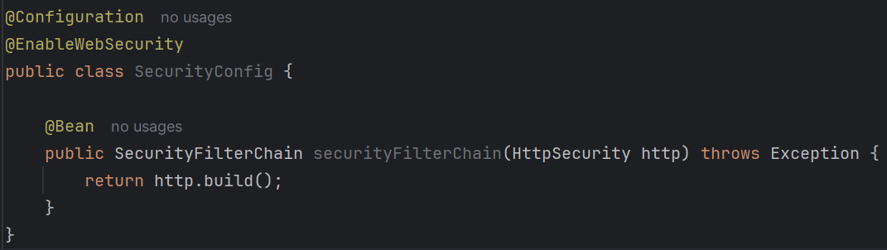
  - Now the filters will not be executed; you need to mention those filters.

